Lab Assignment 8

Chaudhary Hamdan

1905387

Date: 23-03-2022

import numpy as np

import pandas as pd

import matplotlib.pyplot as plt

import seaborn as sns

from sklearn import preprocessing

from sklearn.model_selection import train_test_split

from sklearn.linear_model import LinearRegression

from sklearn.metrics import confusion_matrix

from sklearn.metrics import accuracy_score

from sklearn.metrics import recall_score

from sklearn.metrics import precision_score

from sklearn.metrics import f1_score

df = pd.read_csv('car_sample.csv', encoding = "ISO-8859-1")

1.Find out if following variables are significant or insignificant and need to be dropped.

1. Seller-insignificant
2. offerType-insignificant
3. **abtest-**insignificant

Iv)vehicleType-significant

V)gearbox,

Vi)Model

Vii)Kilometer

Viii)Fueltype

Ix)Brand

X)notRepairedDamage

cols = ['dateCrawled', 'name', 'dateCreated', 'lastSeen']

df.drop(columns=cols, inplace=True)

df.head()

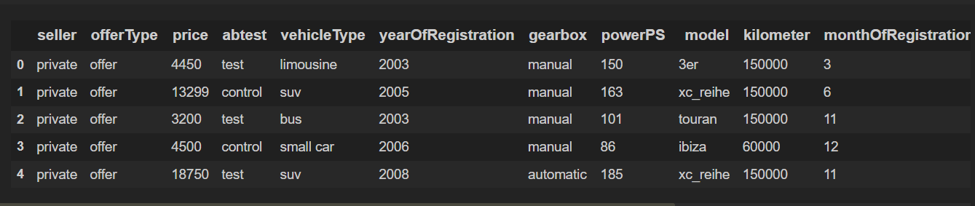

df.info()

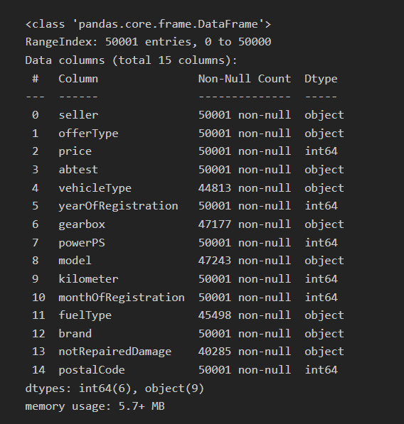

for col in df.columns:

print(col)

print(df[col].value_counts())

print()

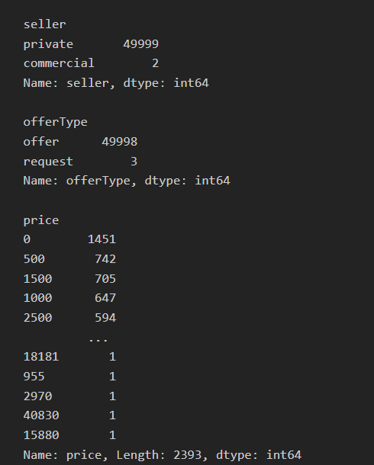

cols = ['seller', 'offerType', 'notRepairedDamage']

df.drop(columns=cols, inplace=True)

df.head()

cols = ['abtest', 'vehicleType', 'gearbox', 'model', 'fuelType', 'brand']

for col in cols:

le = preprocessing.LabelEncoder()

df[col] = le.fit_transform(df[col].astype(str))

df.head()

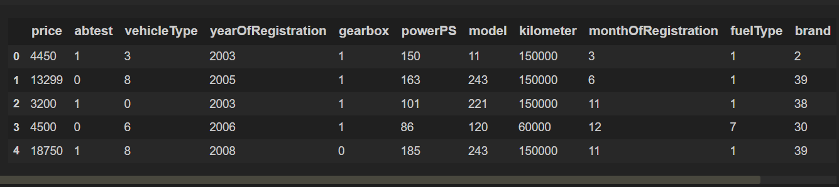

df.corr()

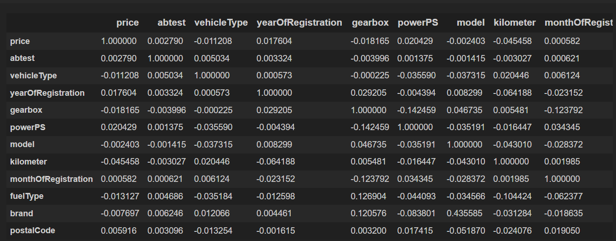

1. Drop insignificant variables from dataframe ‘cars’

cols = ['abtest', 'model', 'monthOfRegistration', 'brand', 'postalCode']

df.drop(columns=cols, inplace=True)

df.head()

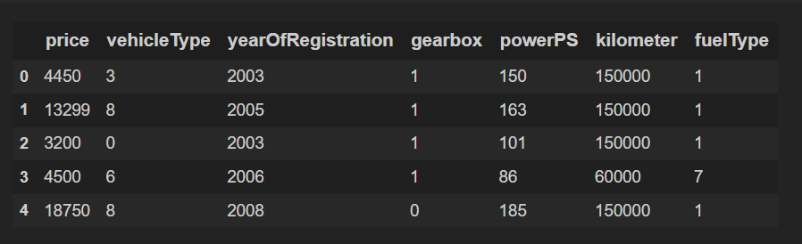

1. Find correlation between all numerical variables and find which variable has the highest correlation with price

cor = df.corr()

sns.heatmap(cor, cmap="YlGnBu", annot=True)

plt.show()

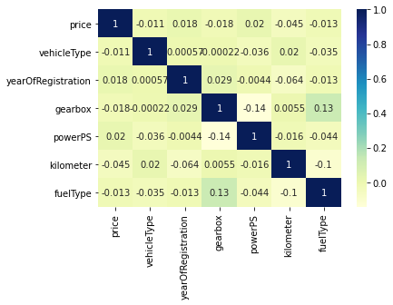

print(cor['price'])

print('Highest: kilometer (abs vale of 0.045458)')

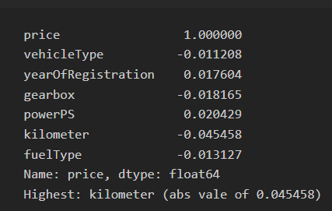

1. Calculate the training data and testing data score using a linear regression model.

x_train, x_test, y_train, y_test = train_test_split(df.drop(columns = ['price']), df['price'], test_size = 0.2)

x_train.shape, y_train.shape, x_test.shape, y_test.shape

algo = "Linear Regression\n"

model = LinearRegression()

model.fit(x_train, y_train)

print(algo)

print('Training error')

y_pred = model.predict(x_train)

e = (y_pred - y_train)

e = e.dot(e)

e /= y_test.shape[0]

e = e**0.5

print(e)

print('Testing error')

y_pred = model.predict(x_test)

e = (y_pred - y_test)

e = e.dot(e)

e /= y_test.shape[0]

e = e**0.5

print(e)

